This is the title of my research presentation

Author I. Presenting¹, Herbert Bystander², Celia von BigBoss³

1. School of Chemistry, University of Chippendale, NSW 2000, Australia
2. Address of Author 2
3. Address of Author 3

E-mail: author.presenting@university.edu.au
Xth year PhD student

Abstract text goes here. Please do not change the font or margins. Please use the supplied reference format, and ensure that any references are called in the text.¹ Maximum abstract length 1 page, including any images.

Lorem ipsum dolor sit amet, consectetur adipiscing elit. Etiam mattis cursus ligula eget semper. Phasellus at cursus justo. Interdum et malesuada fames ac ante ipsum primis in faucibus. Praesent rhoncus ipsum eget rhoncus rhoncus. Phasellus sit amet nulla ex. Phasellus ut nisl maximus, luctus orci ut, venenatis ligula. Quisque consequat lacus sit amet egestas pharetra. Quisque quis tortor ut nisi mollis facilisis. In hac habitasse platea dictumst.

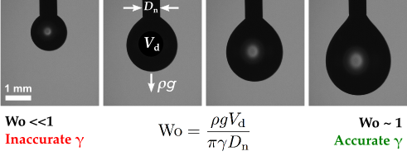

References
- Berry, J. D., Neeson, M. J., Dagastine, R. R., Chan, D. Y., & Tabor, R. F. Measurement of surface and interfacial tension using pendant drop tensiometry. J. Colloid Interface Sci. 454 (2015) 226-237.

